

Central Water Commission
Upper Ganga Basin Organisation, Lucknow
Daily Flood Situation Report Cum Advisories
Date: 06 SEPTEMBER, 2020
FSR No.76 Dated 06-09-2020

1. Weather forecast by IMD

I. SYNOPTIC SITUATION:
- The Monsoon Trough at mean sea level now passes through Amritsar, Meerut, Bahraich, Muzaffarpur, Jalpaiguri andthence eastwards to Nagaland across Assam.
- The cyclonic circulation over southwest Uttar Pradesh & neighbourhood now lies over northeast Rajasthan &neighbourhood and seen between 1.5 & 3.1 km above mean sea level.
- The trough from northwest Uttar Pradesh to Jammu region now runs from the cyclonic circulation over northeastRajasthan & neighbourhood to Jammu region across Haryana and Punjab at 3.1 km above mean sea level.
- The cyclonic circulation over northwest Rajasthan & adjoining Pakistan extending upto 0.9 km above mean sea level has become less marked.
.
II. a) DETERMINISTIC FORECAST (QPF):
Sr. No. | BASIN NAME | SUBBASIN CODE/NAME | QPF (mm)
Sr. No. | BASIN NAME | SUBBASIN CODE/NAME | Day-1 | Day-2 | Day-3
1 | Alaknanda | Alaknanda | 0.1-10 | 0.1-10 | 0.1-10
2 | Bhagirathi | Bhagirathi | 0.1-10 | 0.1-10 | 0
3 | Ganga | Chhatnag to Mirzapur | 0.1-10 | 0 | 0.1-10
3 | Ganga | Narora to Phaphamau | 0 | 0.1-10 | 0.1-10
3 | Ganga | Phaphamau to Ballia | 0 | 0.1-10 | 0.1-10
3 | Ganga | Gomti | 0 | 0.1-10 | 0.1-10
3 | Ganga | Sai | 0 | 0 | 0.1-10
3 | Ganga | Upper Ganga | 0.1-10 | 0.1-10 | 0
4 | Ghaghra | Lower Ghaghra | 0 | 0.1-10 | 0.1-10
4 | Ghaghra | Middle Ghaghra | 0 | 0.1-10 | 0.1-10
4 | Ghaghra | Upper Ghaghra | 0.1-10 | 0.1-10 | 0.1-10
5 | Ramganga | Ramganga | 0.1-10 | 0.1-10 | 0.1-10
6 | Rapti | Rapti | 0.1-10 | 0.1-10 | 0.1-10
7. | Sharda | Sharda | 0.1-10 | 0.1-10 | 0.1-10

II (b) DETERMINISTIC FORECAST (DISTRIBUTION)
 | BASIN NAME | SUBBASIN CODE/NAME | INTENSITY (I) &  SPATIAL DISTRIBUTION (D)
 | BASIN NAME | SUBBASIN CODE/NAME | Day-1 |  | Day-2 |  | Day-3
 | BASIN NAME | SUBBASIN CODE/NAME | I | D | I | D | I | D
1 | Alaknanda | Alaknanda | VL | ISOL | VL | ISOL | VL | ISOL
2 | Bhagirathi | Bhagirathi | VL | ISOL | VL | ISOL | M.Dry | ISOL
3 | Ganga | Chhatnag to Mirzapur | VL | ISOL | M.Dry | ISOL | VL | ISOL
3 | Ganga | Narora to Phaphamau | M.Dry | ISOL | VL | ISOL | VL | ISOL
3 | Ganga | Phaphamau to Ballia | M.Dry | ISOL | VL | ISOL | VL | ISOL
3 | Ganga | Gomti | M.Dry | ISOL | VL | ISOL | VL | ISOL
3 | Ganga | Sai | M.Dry | ISOL | M.Dry | ISOL | VL | ISOL
3 | Ganga | Upper Ganga | L | SCT | L | SCT | M.Dry | ISOL
4 | Ghaghra | Lower Ghaghra | M.Dry | SCT | L | SCT | M | SCT
4 | Ghaghra | Middle Ghaghra | M.Dry | SCT | VL | ISOL | M | SCT
4 | Ghaghra | Upper Ghaghra | VL | ISOL | VL | ISOL | L | ISOL
5 | Ramganga | Ramganga | L | SCT | L | SCT | L | SCT
6 | Rapti | Rapti | VL | ISOL | M | SCT | M | SCT
7. | Sharda | Sharda | L | SCT | L | ISOL | L | SCT

III. HEAVY RAINFALL WARNING:

NAME OF BASIN | NAME OF SUB- BASIN | Day-1 |  | Day-2 |  | Day-3
NAME OF BASIN | NAME OF SUB- BASIN | I | D | I | D | I | D
Alaknanda | Alaknanda
Bhagirathi | Bhagirathi
Ganga | Chhatnag to Mirzapur
Ganga | Narora to Phaphamau
Ganga | Phaphamau to Ballia
Ganga | Gomti
Ganga | Sai
Ganga | Upper Ganga
Ghaghra | Lower Ghaghra
Ghaghra | Middle Ghaghra
Ghaghra | Upper Ghaghra
Ramganga | Ramganga
Rapti | Rapti
Sharda | Sharda

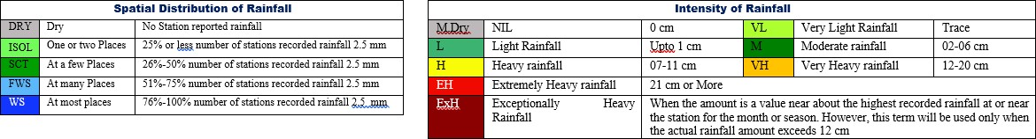

IV. PROBABILISTIC FORECAST
S. No. | BASIN NAME | SUBBASIN CODE/NAME | Day-1 |  |  |  |  |  | Day-2 |  |  |  |  |  | Day-3
S. No. | BASIN NAME | SUBBASIN CODE/NAME | 0 mm | 0.1-10 mm | 11-25 mm | 26-50 mm | 51-100 mm | >100 mm | 0 mm | 0.1-10 mm | 11-25 mm | 26-50 mm | 51-100 mm | >100 mm | 0 mm | 0.1-10 mm | 11-25 mm | 26-50 mm | 51-100 mm | >100 mm
1 | Alaknanda | Alaknanda |  | 75-100 |  |  |  |  |  | 75-100 |  |  |  |  |  | 75-100
2 | Bhagirathi | Bhagirathi |  | 75-100 |  |  |  |  |  | 75-100 |  |  |  |  | 75-100 | 5-25
3 | Ganga | Chhatnag to Mirzapur | 25-50 | 50-75 |  |  |  |  | 50-75 | 25-50 |  |  |  |  |  | 75-100
3 | Ganga | Narora to Phaphamau | 50-75 | 25-50 |  |  |  |  |  | 75-100 |  |  |  |  |  | 75-100
3 | Ganga | Phaphamau to Ballia | 75-100 | 75-100 |  |  |  |  | 25-50 | 50-75 |  |  |  |  |  | 75-100
3 | Ganga | Gomti | 75-100 |  |  |  |  |  |  | 75-100 |  |  |  |  |  | 75-100
3 | Ganga | Sai | 75-100 |  |  |  |  |  | 50-75 | 25-50 |  |  |  |  |  | 75-100
3 | Ganga | Upper Ganga |  | 75-100 |  |  |  |  |  | 75-100 |  |  |  |  | 75-100 | 5-25
4 | Ghaghra | Lower Ghaghra | 50-75 | 25-50 |  |  |  |  |  | 75-100 |  |  |  |  |  | 75-100
4 | Ghaghra | Middle Ghaghra | 50-75 | 25-50 |  |  |  |  |  | 75-100 |  |  |  |  |  | 75-100
4 | Ghaghra | Upper Ghaghra |  | 75-100 |  |  |  |  |  | 75-100 |  |  |  |  |  | 75-100
5 | Ramganga | Ramganga |  | 75-100 |  |  |  |  |  | 75-100 |  |  |  |  |  | 75-100
6 | Rapti | Rapti |  | 75-100 |  |  |  |  |  | 75-100 |  |  |  |  |  | 50-75 | 25-50
7. | Sharda | Sharda |  | 75-100 |  |  |  |  |  | 75-100 |  |  |  |  |  | 75-100

2. Summary of flood situation as per CWC flood forecasting network

Flood Situation on 06 September 2020
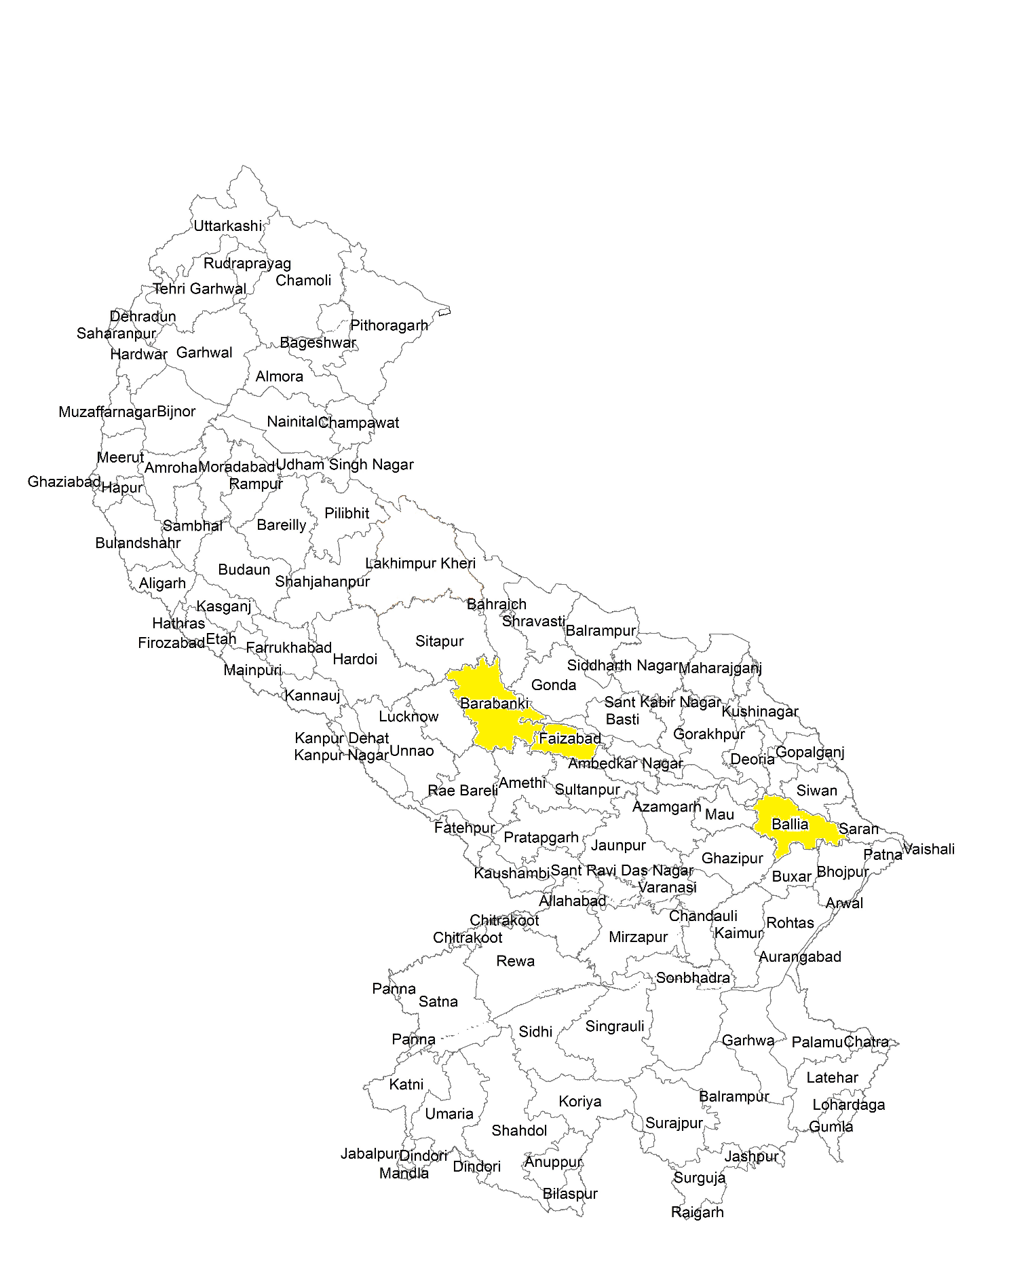

2.1 Rainfall Situation

Amount of rainfall recorded at 8:30 hours IST of today ((≥50 mm or more)
Name of Place (State) | Rainfall (in mm)
Nill

2.2 LEVEL FORECAST
LEVEL FORECAST
S.No. | Flood Situations | No. of Forecasting Sites
A. | Extreme Flood Situation:
A. | (Site (s) where the previous Highest Flood Level (HFL) is exceeded or equalized) | 0
B. | Severe Flood Situation :
B. | (Site(s) where water Level touching or exceeding the Danger Level but below Highest Flood Level(HFL) | 01
C. | Above Normal Flood Situation:
C. | (Site (s) where water level touching or exceeding the warning Level but below Danger Level) | 04
Total Numbers of Sites above Warning Level (A+B+C) |  | 05
INFLOW FORECAST
Number of Sites for which inflow forecasts issued: |  | 00
(Where inflow are equal or exceed the specified Threshold Limit for a particular reservoir/ barrage) |  | 00

2.3 Above Normal (Water Level touching or exceeding the warning Level but below Danger Level)

Name of river | Flood Forecasting Sites | District | State | Danger Level(m) | Warning Level (m) | Previous Highest |  | Actual Level |  |  | Forecast
 |  |  |  |  |  | Level  (m) | Date | Level  (m) | Time | Trend | Level  (m) | Date | Time | Trend
Ganga | Kachhla bridge | Budaun | U.P | 161.00 | 162.00 | 162.79 | 2010 | 161.32 | 0800 | F | 161.20 | 07.09.20 | 0800 | F
Ghaghra | Turtipar | Ballia | U.P | 64.01 | 63.01 | 66.00 | 1998 | 63.4 | 0800 | F | 63.350 | 07.09.20 | 0800 | F
Ghaghra | Elgin Bridge | Barabanki | U.P | 106.07 | 105.07 | 107.616 | 2014 | 105.286 | 0800 | F | 105.10 | 07.09.20 | 0800 | F
Ghaghra | Ayodhya | Faizabad | U.P | 92.73 | 91.73 | 94.01 | 2009 | 91.79 | 0800 | F | 91.65 | 07.09.20 | 0800 | F

2.4 Severe Flood Situation (Water Level touching or exceeding the Danger Level but below Highest Flood Level (HFL))
Name of river | Flood Forecasting Sites | District | State | Danger Level(m) | Warning Level (m) | Previous Highest |  | Actual Level |  |  | Forecast
 |  |  |  |  |  | Level(m) | Date | Level(m) | Time | Trend | Level (m) | Date | Time | Trend
Ganga | Ballia | Ballia | U.P | 57.615 | 56.615 | 60.39 | 2016 | 58.06 | 0800 | F | 57.65 | 7.09.20 | 0800 | F

2.5 Extreme Flood Situation (Water Level exceeded or equalized Highest Flood Level (HFL))

Name of river | Flood Forecasting Sites | District | State | Danger Level(m) | Warning Level (m) | Previous Highest |  | Actual Level |  |  | Forecast
 |  |  |  |  |  | Level(m) | Date | Level(m) | Time | Trend | Level (m) | Date | Time | Trend

Note - No Station is in this situation Dated 06.09.2020

2.6 Inflow Forecast
Name of river | Flood Forecasting Sites | District | State | HFL(m) | FRL(m) | Previous Highest |  | Actual Level |  |  | Forecast
 |  |  |  |  |  | Discharge  (Q) | Date | Discharge  (Q) | Time | Trend | D  (Q) | Date | Time | Trend

Note - No Station is in this situation Dated 06.09.2020

Advisory on Hydro Meteorological Situation Expected from 07-09-2020 to 08-08-2020
As per rainfall pattern given in section II, Alaknanda, Bhagirathi & Gangarivers are expected to receive light to very light rain at scattered areas in next 48 hrs.Ghaghra, Ramganga, Sharda &Rapti river basins are expected to receive light to very light rain at scattered to widespread areas in next 48 hours. Water level at most of CWC stations are expected to fall in next 48 hours. Level forecast will be issued if the level of river at stations are likely to touch or cross warning level. From the given QPF, Above normal flood like situation is expected in Ganga, Ghaghra, Rapti& Sharda river basins.

अधिशासीअभियंता
मध्य गंगा मण्डल -1 लखनऊ

